Exercise:1

x=(0:0.01:4\*pi);

y=sin(x);

plot(x,y,'\*g')

title("plot of sine wave")

ylabel("y values")

xlabel("x values")

grid on

figure(gcf)

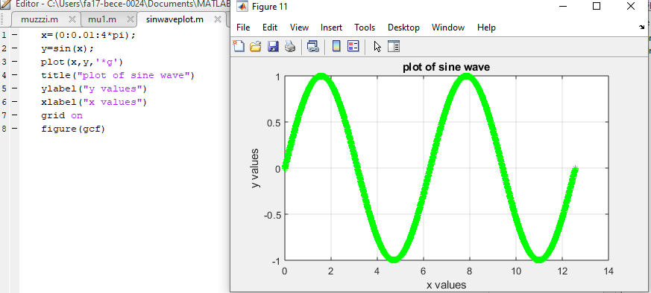

TASK 1

figure

x=(0:pi/20:2\*pi);

y1=sin(x);

y2=cos(x);

plot(x,y1,'\*g',x,y2,'^k')

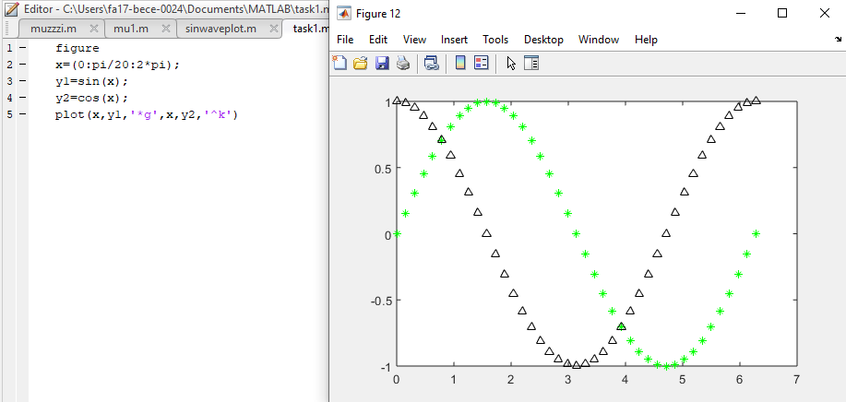

TASK2:

figure

x=(0:pi/20:2\*pi);

y1=sin(x);

y2=cos(x);

plot(x,y1,'--',x,y2,':')

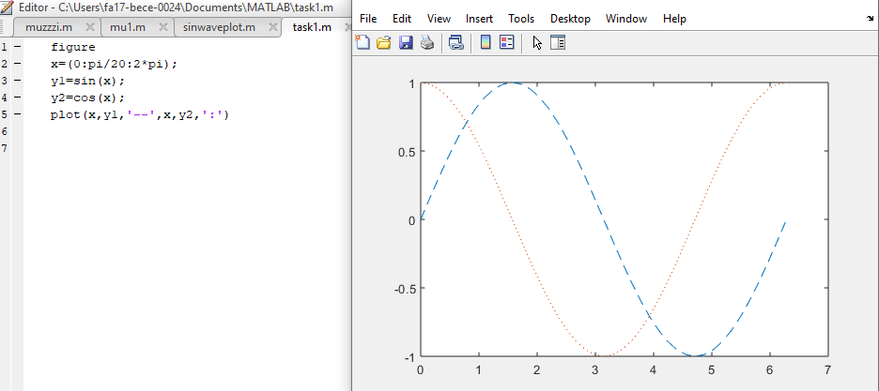

TASK 3:

figure

x=(0:pi/20:2\*pi);

y1=sin(x);

y2=cos(x);

subplot(2,1,1)

plot(x,y1,'--g')

subplot(2,1,2)

plot(x,y2,':k')

